5. PROJECT DEVELOPMENT PHASE
Date | 30 SEPTEMBER 2026
Team ID | 6ab277cdba33564c8ba151a5
Project Name | Import Data using Transform Maps (Spreadsheet)
Maximum Marks | 4 Marks

Project Name: Import Data using Transform Map (Spreadsheet)
Module: ServiceNow – Import Set & Transform Map
5.1 Spreadsheet Preparation
Employee data was prepared in spreadsheet format with Employee ID, Name, Department and Location.
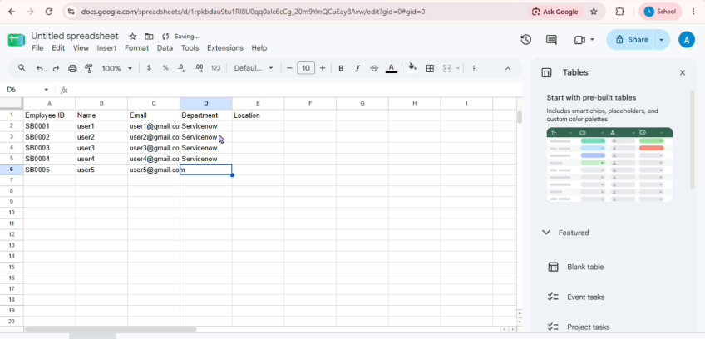
5.2 Import Set Creation
The prepared spreadsheet was imported into ServiceNow using the Import Set feature. The source file and import table were configured for the employee data.
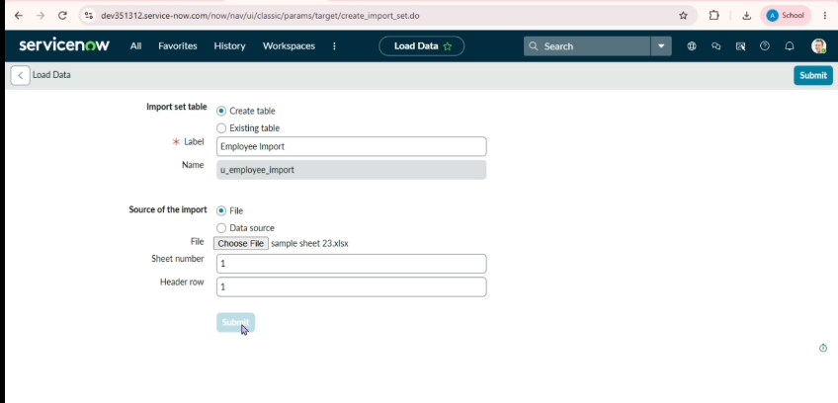
5.3 Transform Map Creation
A Transform Map was created to transfer the imported employee data from the import set table to the target table.
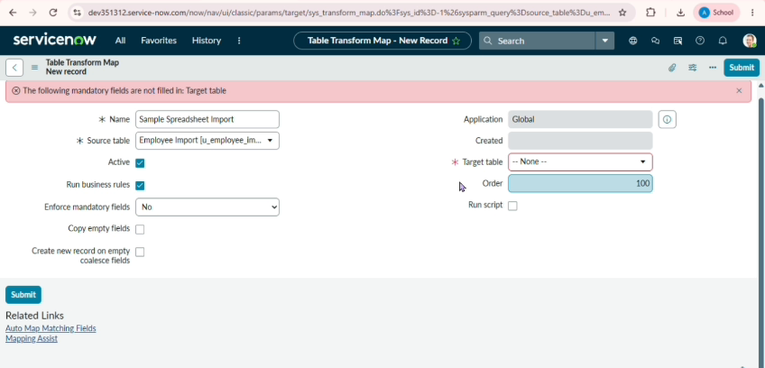
5.4 Field Mapping
The source fields were mapped with the corresponding fields in the target table so that the employee information could be transformed correctly.
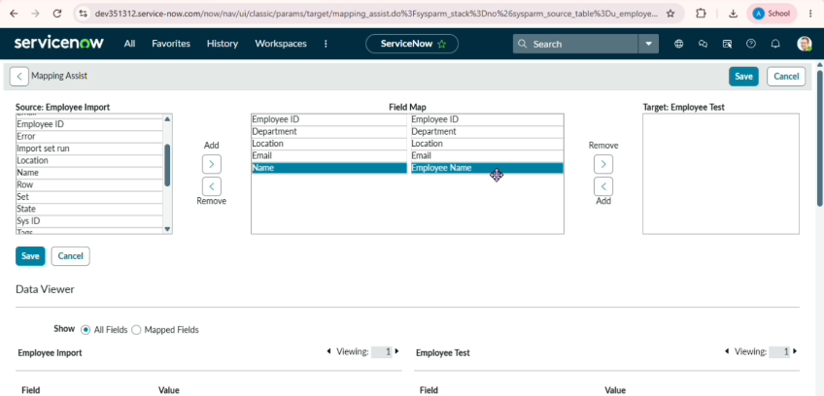
5.5 Final Output
The spreadsheet data was successfully transformed and imported into the target table. The imported employee records were verified in ServiceNow.
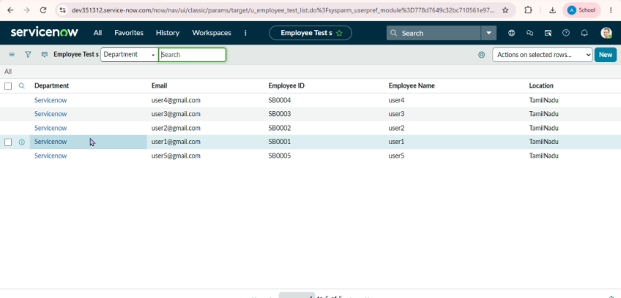
5.6 Report Creation
Reports were created from the imported employee table to display employee information in a clear and useful format.
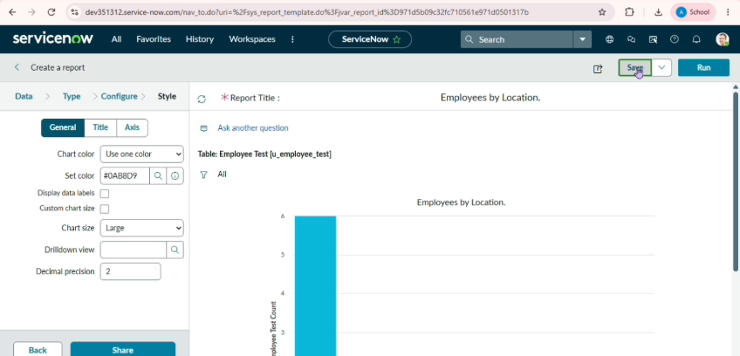
5.7 Dashboard Output
The reports were added to the Employee Analytics Dashboard to provide a visual summary of the employee data.
